Criterion B: Design

Flowchart 1: Basic flow of actions

dashboard

Dashboard

Register new appointment

Check appointment

Flowchart 2: Detailed flow chart of patient panel

Patient.tsx

Check appointment

Valid patient id

Shows appointment status

No

No appointment found

Design of Solution

The following design below is a prototype design made with Figma to visualize the product’s design. It represents only the function and the layout. The actual design was made using Vite framework, React and tailwindcss.

App.jsx

Entry point of the application where the user can go into patient, doctor or receptionist page.

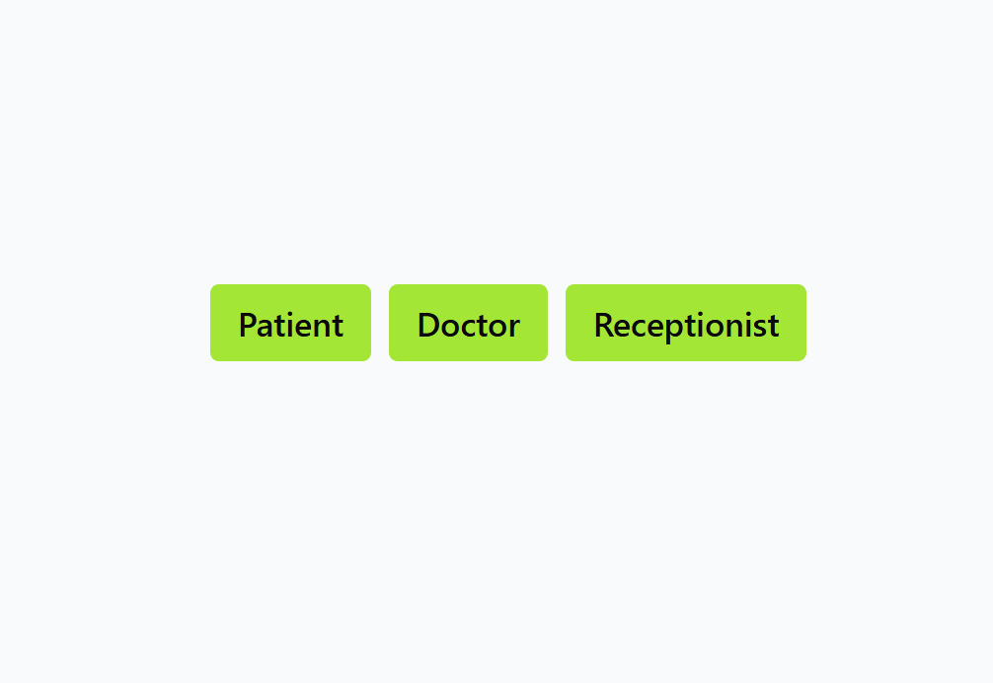

Patient.tsx

Here the client will be initially prompted to enter the their patient id to know their status of their appointments, and if the client has already booked an appointment he can check the status of the appointment, if he hasn’t booked the appointment he will move forward to click the register option to fill out the details and book an appointment and

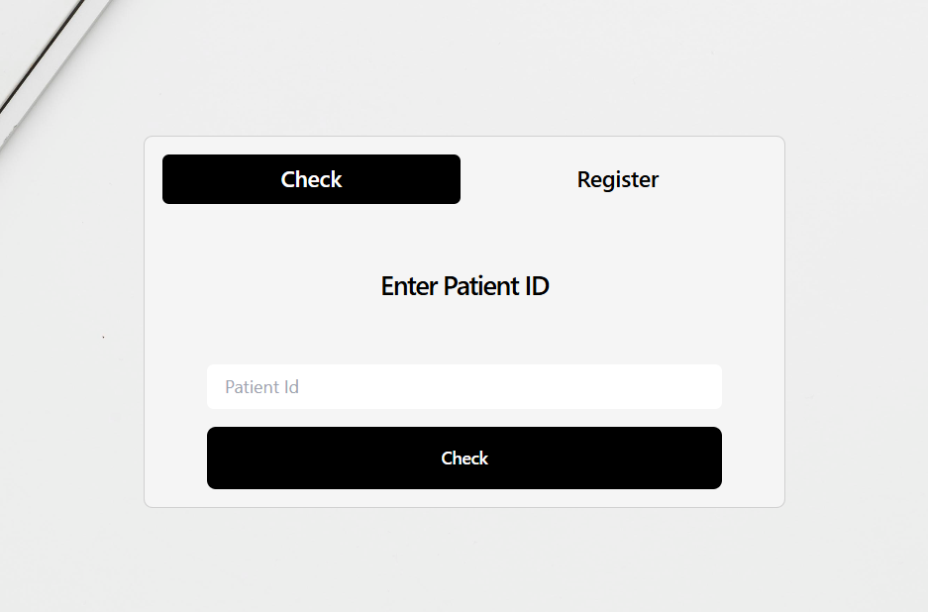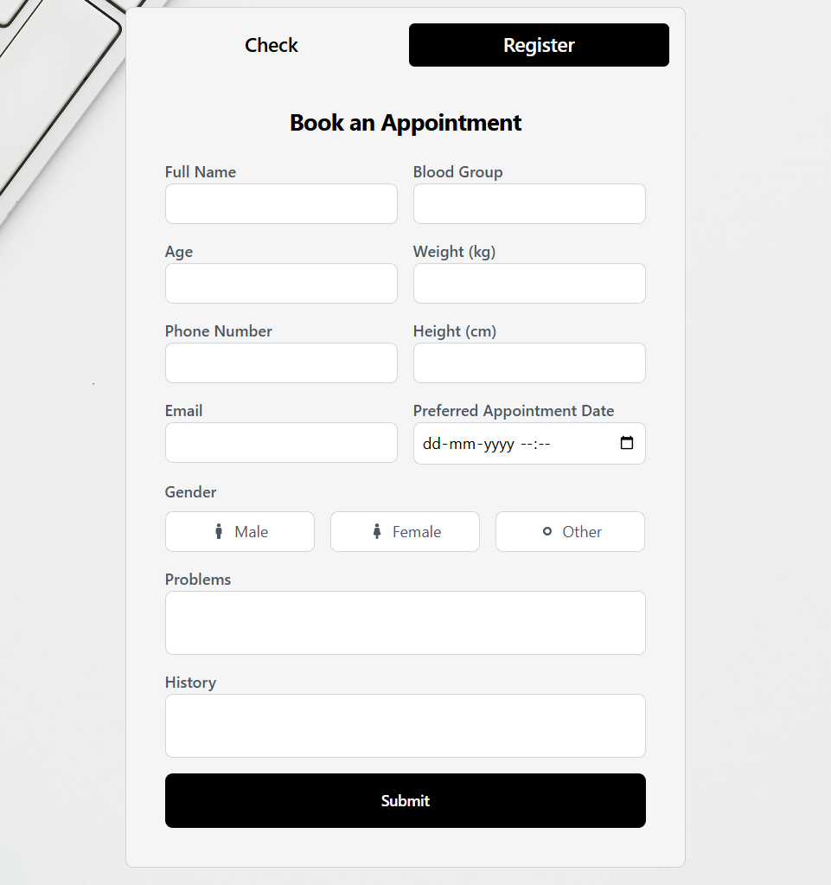

ConfirmationPage.tsx

Here after a successful appointment it will show the details of the booked appointment.

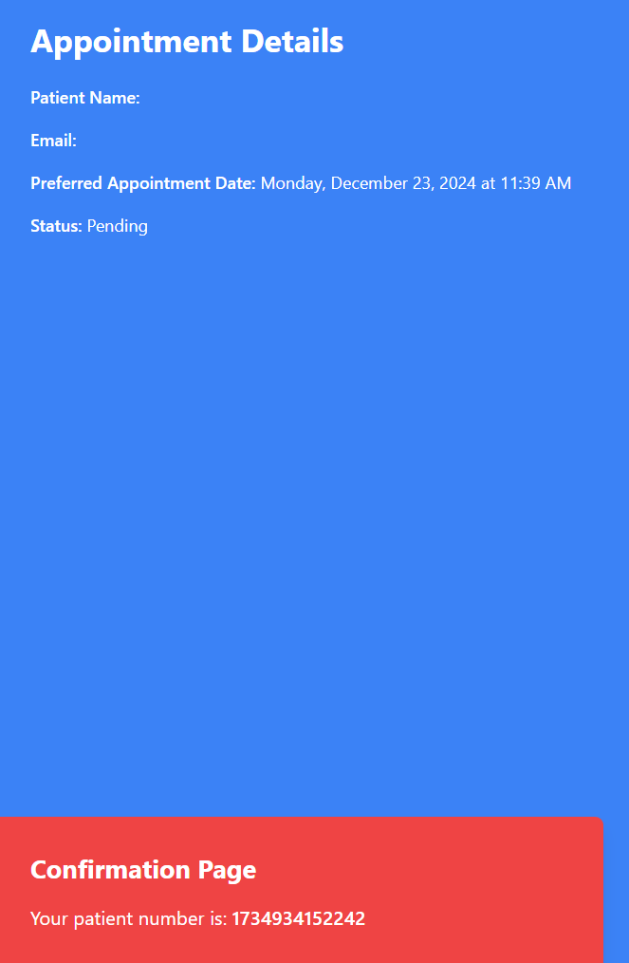

Doctor.tsx/Patient.tsx

When this option is clicked it will take you to the designated dashboard and then will show you the notification first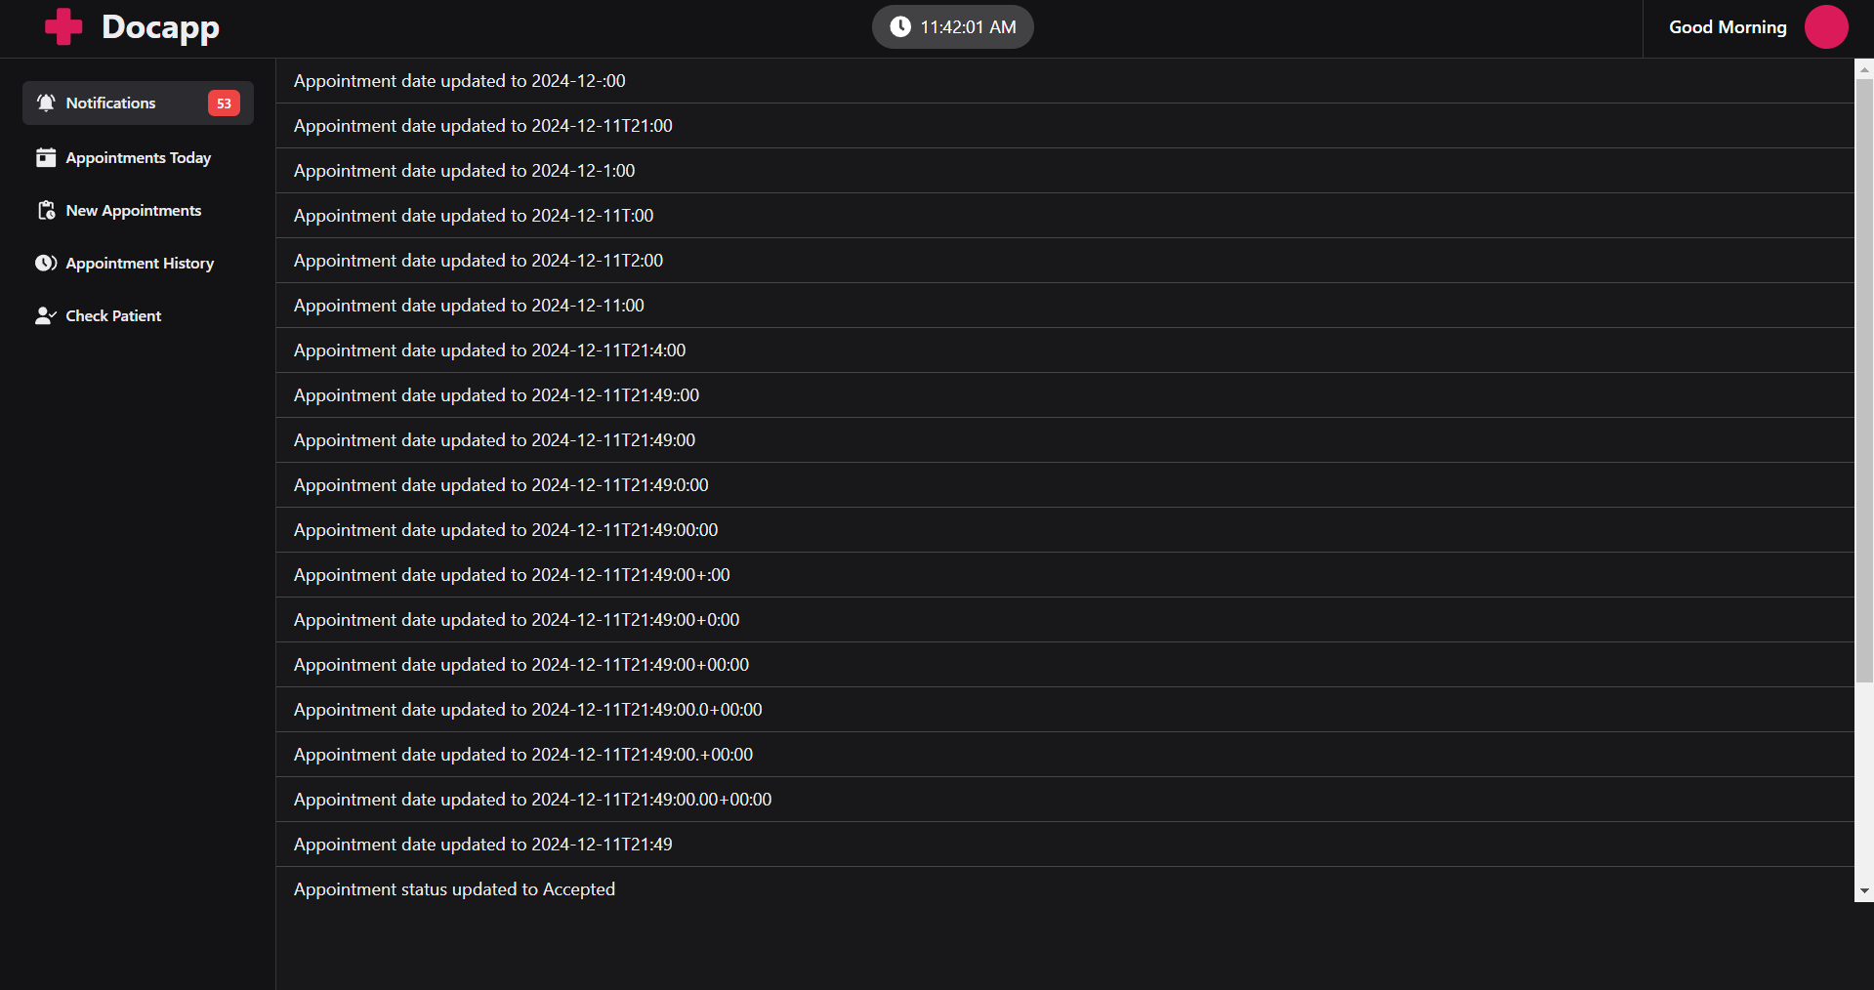

Appointments Today

Shows the appointments booked today

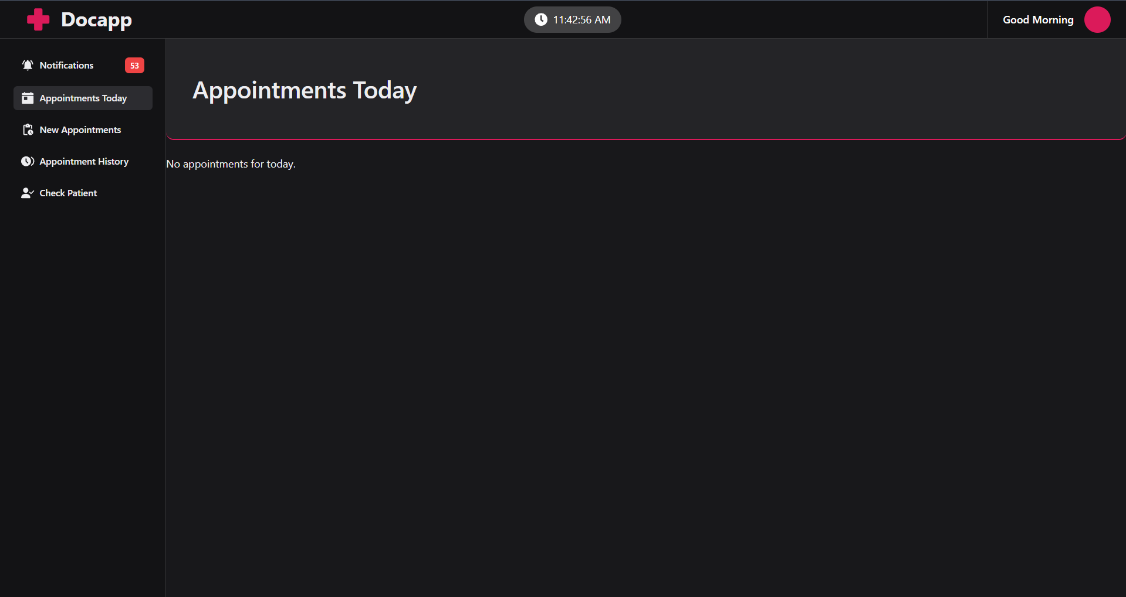

New appointments

This shows all the new appointments. 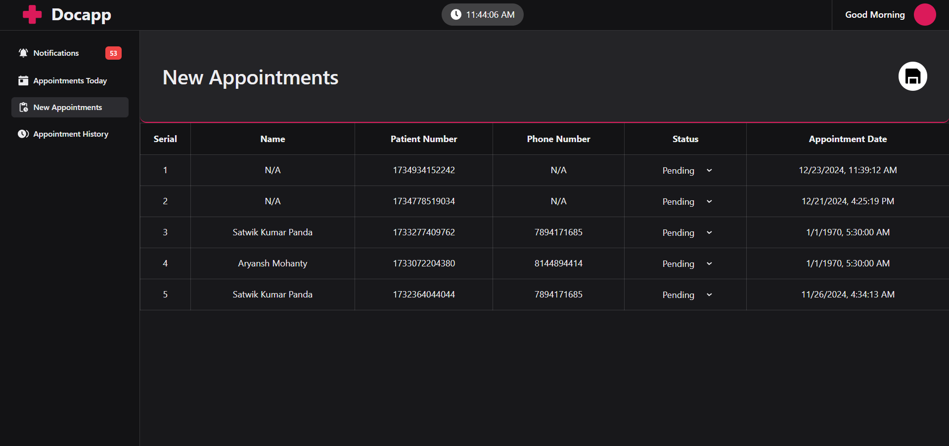

Appointment History

This shows all the appointments which are colour coded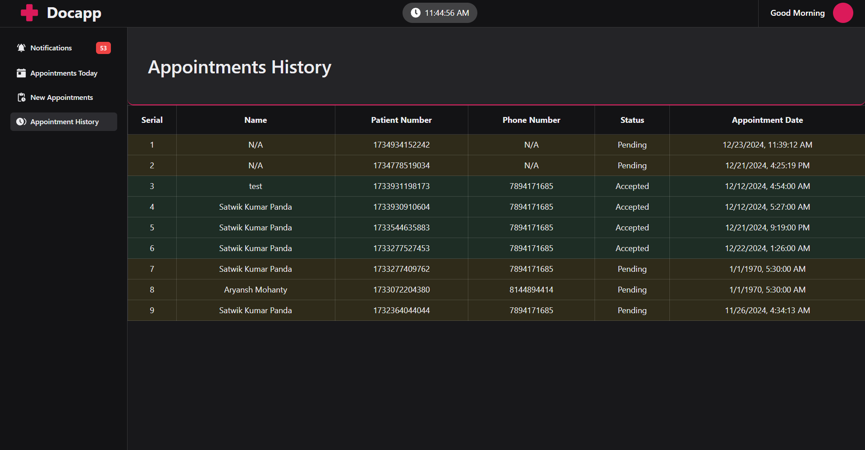

Add Patients for the receptionist:

This here allows the receptionist to add patients directly. 